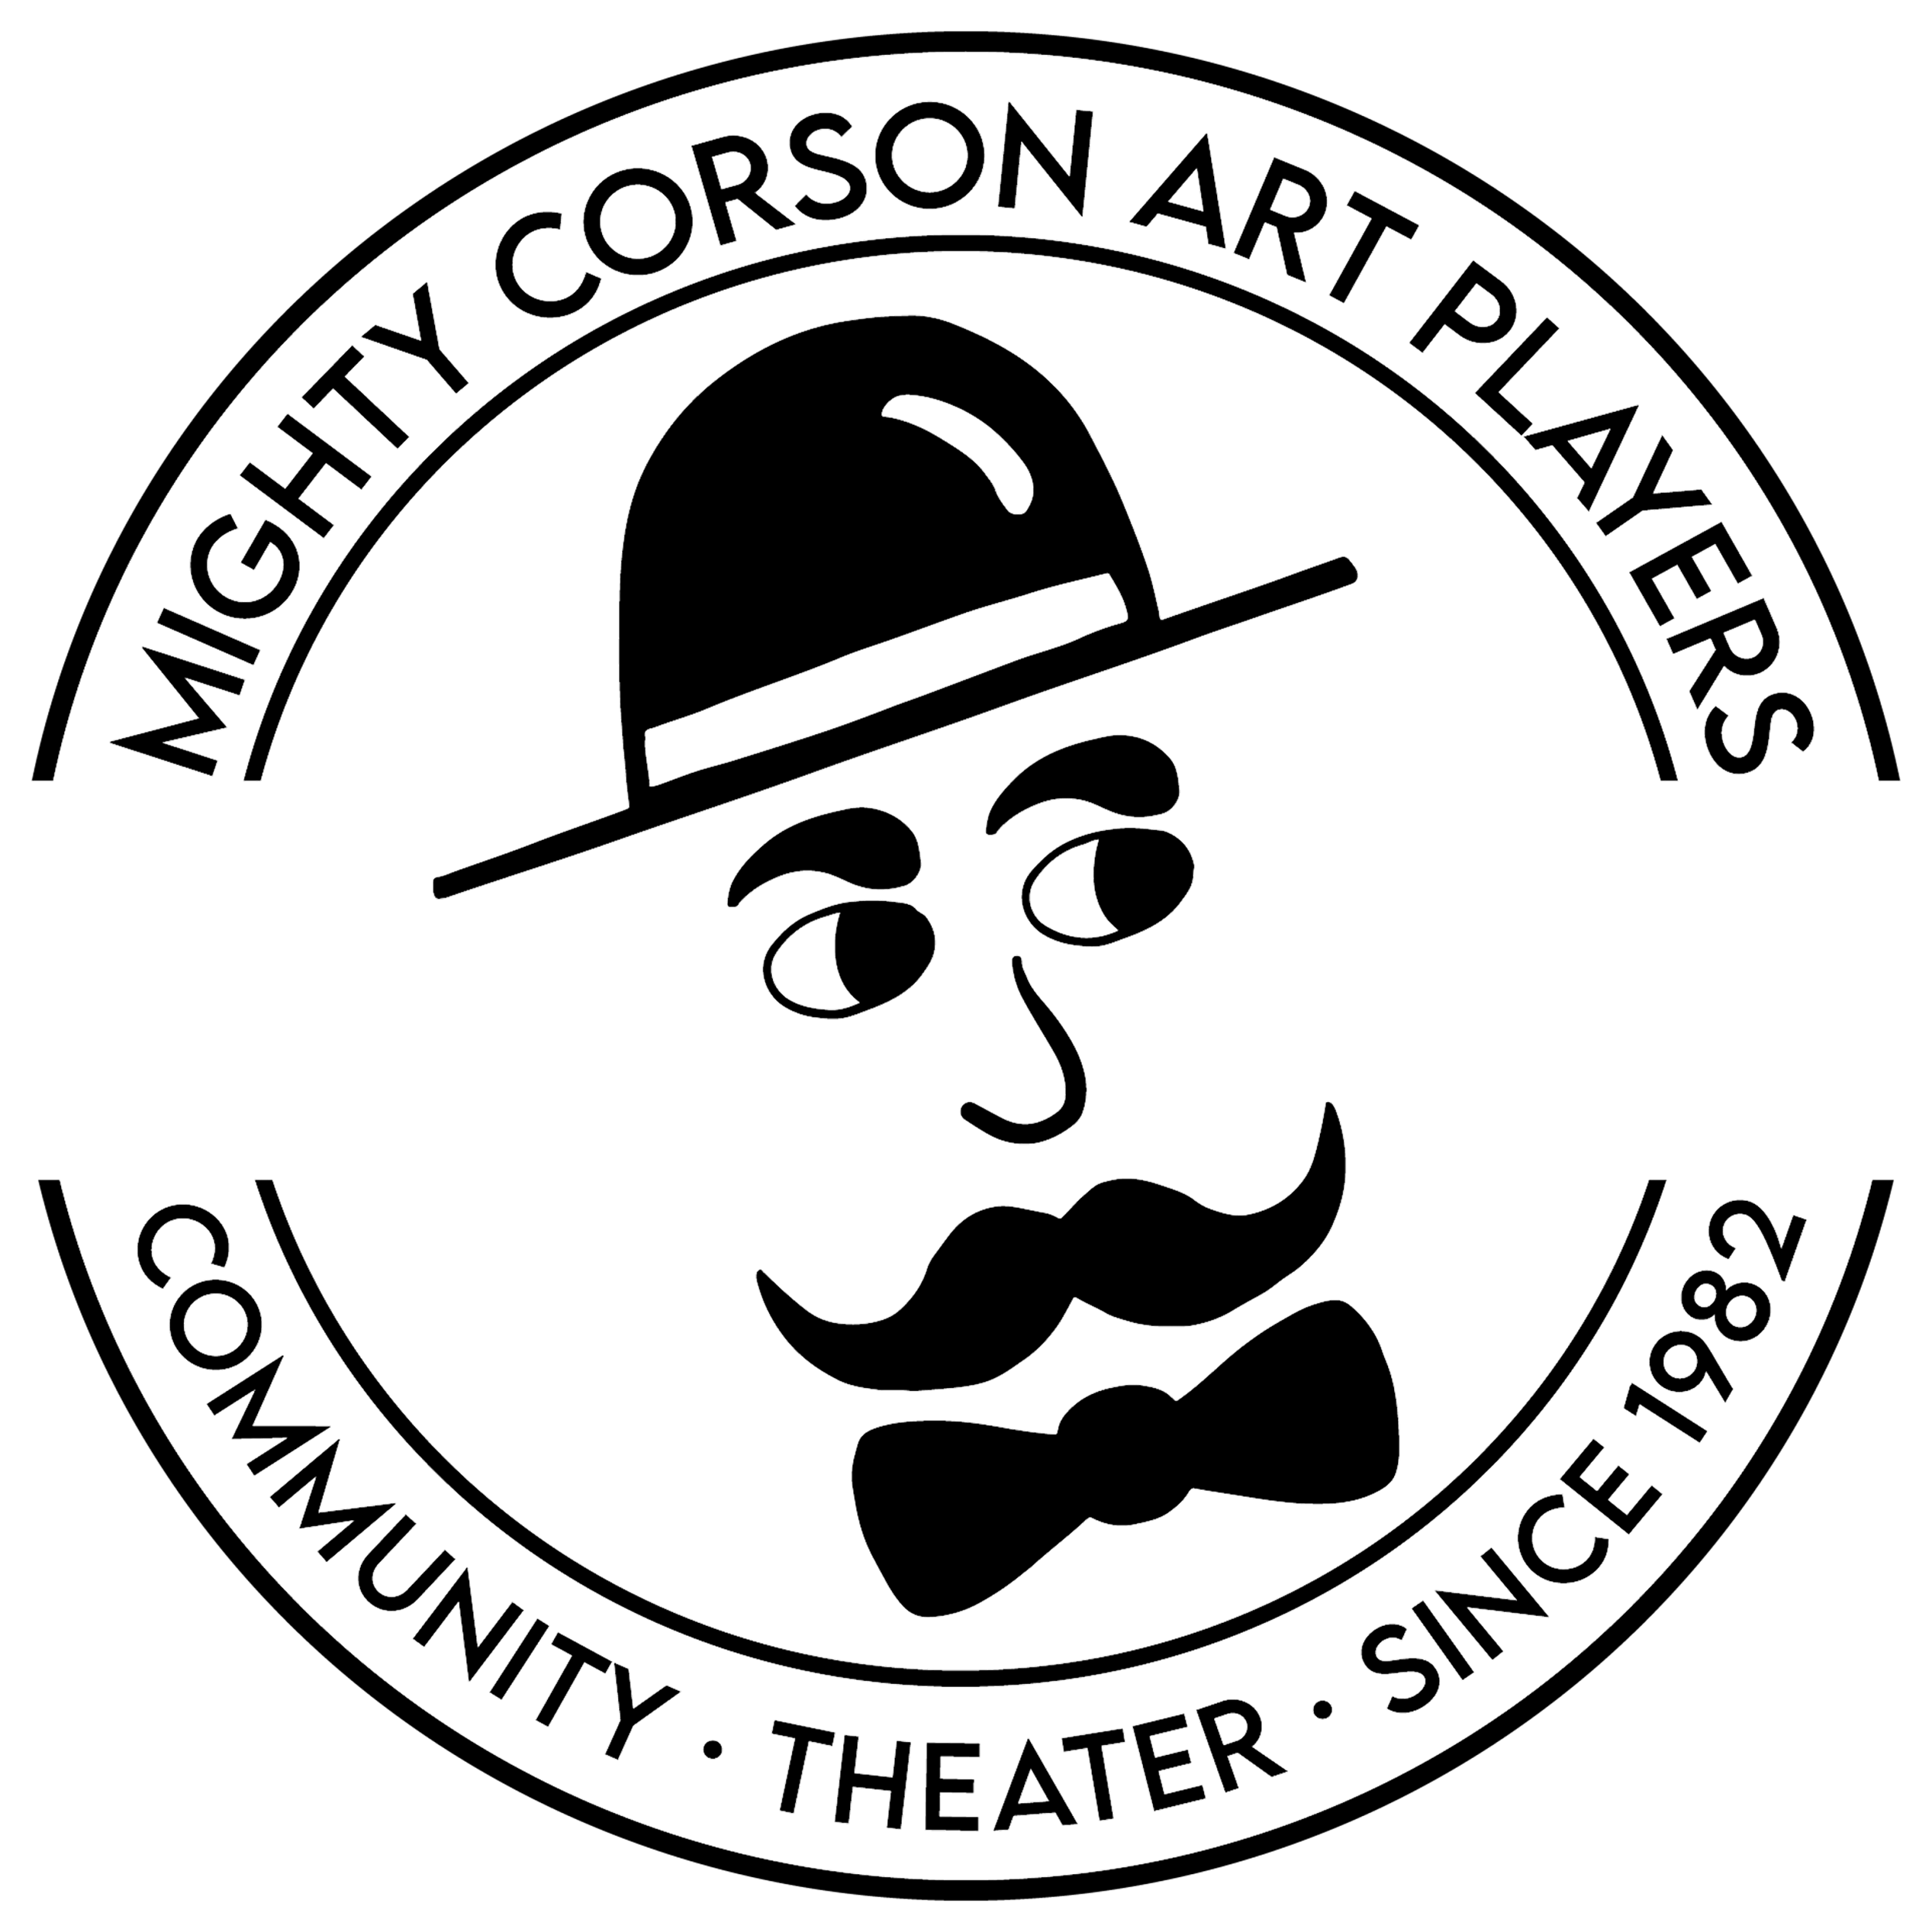
Mighty Corson Art Players
[title of show]

Audition Form
Show Dates: April 19 - 28
Name |  | Address
Age |  | Email
Height |  | Cell Phone
Vocal Range |  | Home Phone
Role(s) auditioning for? |  | Are you comfortable with stage intimacy? | Please circle one:  YES NO
Would you accept any role?  Would you accept an understudy role? | Please circle one:  YES NO  YES NO | Please circle if you would be willing to do any of the following. | CUT HAIR  SHAVE FACIAL HAIR  DYE HAIR

Experience Conflicts
Production | Role | Date |  | Please list conflicts here and on the back.

I understand that rehearsal is for the benefit of all involved and will be respectful of the cast and crew by being prompt and ready to go at rehearsal start. Except in case of emergency, I will notify the director or stage manager at least 24 hours ahead of an unplanned absence from rehearsal.

Signature Date

